**Brainstorming & Idea Prioritization Template**

|  |  |
| --- | --- |
| Date | 31 October 2025 |
| Team ID | NM2025TMID02536 |
| Project Name | Laptop Request Catalog Item in ServiceNow |
| Maximum Marks | 4 Marks |

**Brainstorming & Idea Prioritization Template**

Brainstorming provides a creative environment that encourages team members to collaborate and generate innovative ideas. In this project, our goal was to develop an automated system for requesting laptops using ServiceNow. The brainstorming session allowed us to identify current pain points in the manual laptop request process, generate possible solutions, and prioritize feasible ideas for implementation.

## Step 1: Team Gathering, Collaboration and Problem Selection

Our team collaborated to identify a real-world process that could be improved using ServiceNow automation. After analyzing various organizational workflows, we selected 'Laptop Request Catalog Item' as our project focus. The main challenge was to replace the manual and paper-based laptop request process with a digital, dynamic, and user-friendly catalog form. This would simplify the request experience and ensure data accuracy, tracking, and faster approvals.

## Step 2: Brainstorming, Idea Listing and Grouping

We listed all potential ideas for creating an effective laptop request catalog item in ServiceNow. Each idea was discussed, grouped, and evaluated based on its feasibility, user impact, and automation capability.

Ideas generated included:

* Creating a dynamic catalog form with fields that adjust based on user input.
* Adding reset and clear form functionality for convenience.
* Integrating approval workflows for managers and IT teams.
* Providing automated email notifications for each stage of the request.
* Tracking and auditing all changes for governance and reporting.

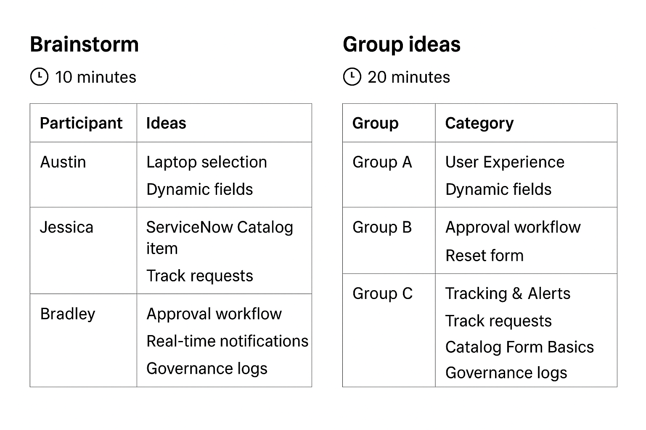

## Step 3: Idea Prioritization

After listing all ideas, we prioritized them using impact vs. feasibility analysis. Ideas that offered the most user benefit and were easier to implement were selected for the initial phase of development.

Prioritized ideas:

1. Developing the dynamic laptop request form with guided input fields.
2. Automating approval and notification workflows.
3. Implementing request tracking and audit trail functionality.
4. Adding a reset button to simplify form completion.

